A Bold Story by a Small Company

Contents

Chapter 1 The Journey to Pure Beauty
Chapter 2 Sander Sinot
Chapter 3 Annie Buzantian
Chapter 4 Puredistance I Perfume
Chapter 5 Puredistance and Vienna
Chapter 6 Puredistance Perfume Lounge Vienna
Chapter 7 Design and Manufacturing
Chapter 8 Pure Swarovski Crystal
Chapter 9 About the Founder
Chapter 10 Pure Exclusivity
Chapter 11 Mystery and Paradox
Crystal Column 'Crystal & Gold'
in White Giftbox - 2750 Euro

Chapter 12 Puredistance Facts

1. The Journey to Pure Beauty
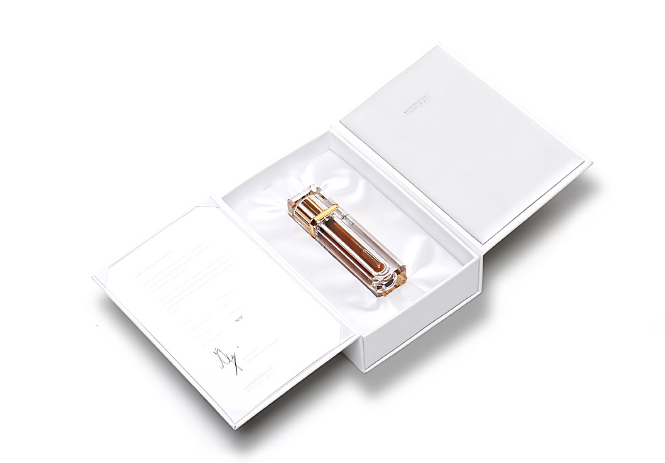

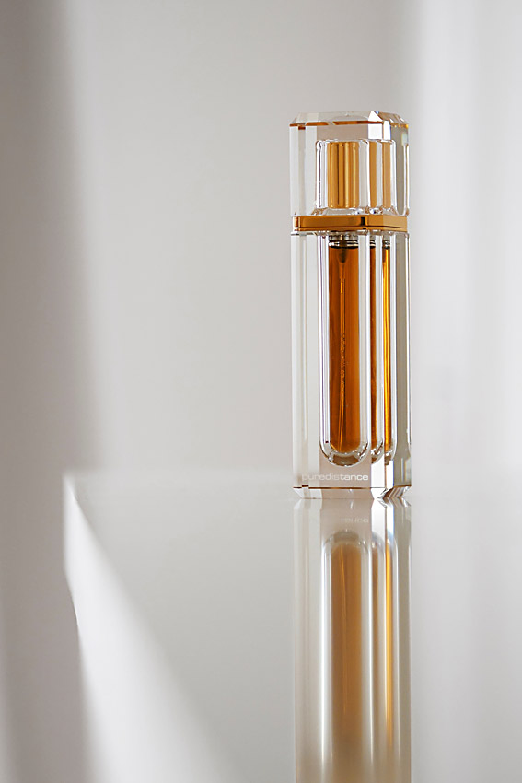
This story is about Puredistance, the perfume that in all its facets represents the quest for beauty and pureness. Not only by showing the apparent contradiction of a mysterious and complicated perfume set in a clear crystal flacon, also by telling the stories of remarkable people that got caught by the concept and contributed by lending their exclusive knowledge and positive energy to Puredistance.
Puredistance - Franziskanerplatz 6
1010 Vienna - Austria

T +43 (0)1 513 55 18
E vienna@puredistance.com

Puredistance is an ode to personal perception of beauty and consequently the appreciation of pure exclusiveness.
Crystal Column 'Crystal & Gold'
2750 Euro

2. Sander Sinot
The concept of a perfume spray hidden inside a pure Crystal Column was envisioned by the world renowned designer Sander Sinot.

Sander Sinot has a reputation for forms of striking and sublime simplicity. He believes in timeless proportions and pure, clean lines crafted to create a classic and uncomplicated shape.

His exceptional design for the ‘Puredistance I’ perfume is one of a kind: the concept of a perfume spray inside a Crystal Masterpiece is unique in the history of perfume bottles.

3. Annie Buzantian
Sander Sinot - Designer Crystal Column

Annie Buzantian, Master Perfumer at the fragrance house Firmenich is the creator of Puredistance I and some of the most successful fragrances of the decade.

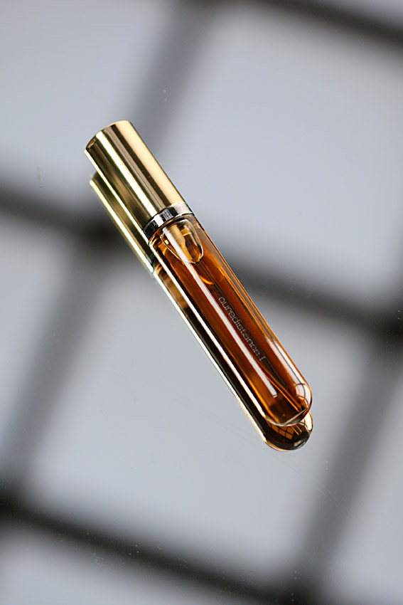
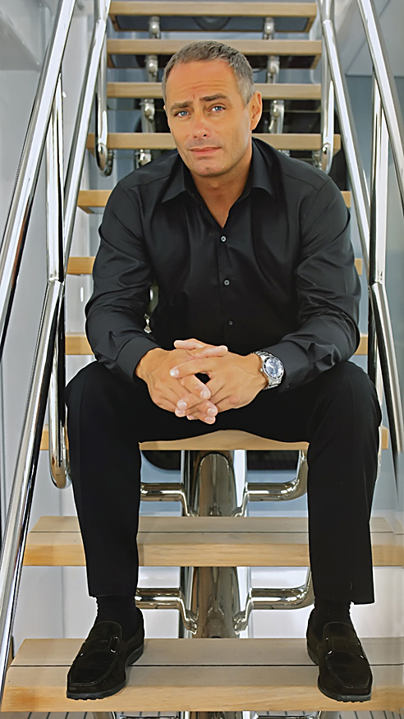
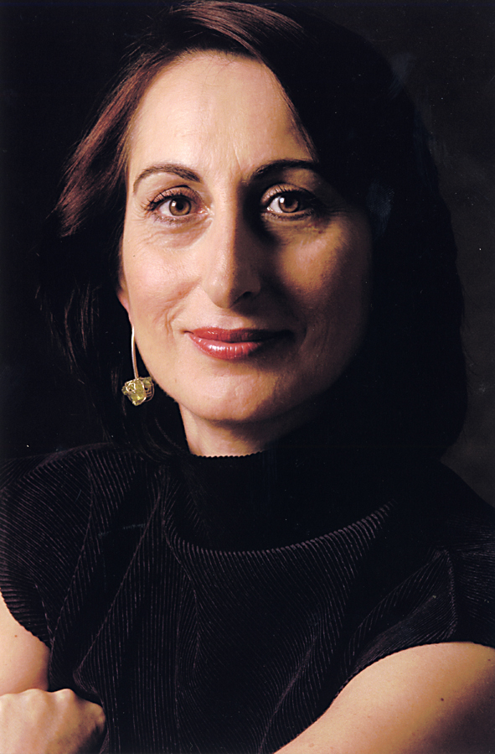
Annie Buzantian was first exposed to the exotic ingredients of perfumery in Constanza, Romania, where she was born. Later Annie Buzantian spent time in Lebanon, surrounded by the beautiful flowers of the Mediterranean, a memory that continues to inspire her to this day.

Annie Buzantian’s career began by training with Elie Roger, one of the most famous and demanding Master Perfumers. In recognition of her enormous successes, Annie Buzantian was awarded the title Master Perfumer in 1998. On top of that she was presented with the Lifetime Achievement Award by the American Society of Perfumers (ASP).
Annie Buzantian - Master Perfumer Puredistance I

Annie Buzantian originally created ‘Puredistance I’ for herself and still considers it her Personal Masterpiece. When by chance she learnt about
the concept of Puredistance, she felt the two belonged to each other and ‘Puredistance I’ was born.

4. Puredistance Perfume
‘Puredistance I’ is intriguingly complex. The perfume’s rich and sophisticated tones are a discreet statement of elegance.

The perfume opens as top note with a fresh, ozone-tangerine blossom blend with a hint of cassis, complemented with neroli bigarade and crisp watery nuances.
Refill - 17.5 ml. Perfume Spray - 165 Euro

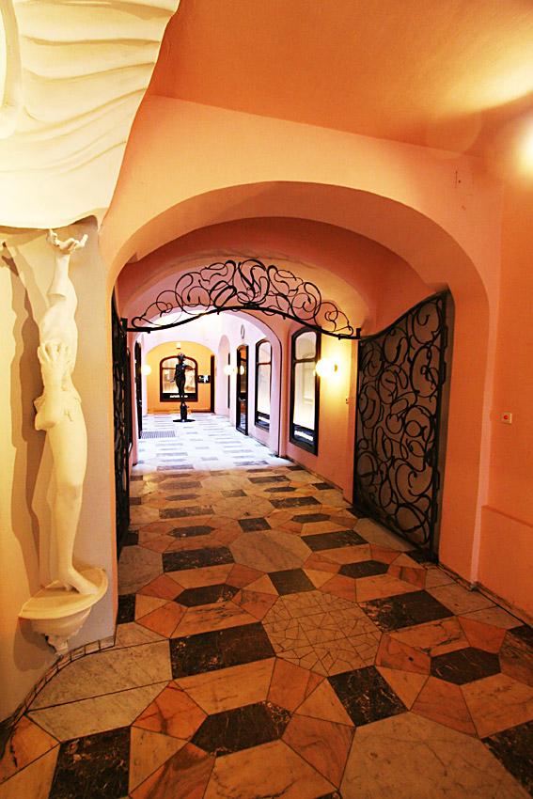
The heart of the fragrance warms to a sophisticated, modern blend of magnolia, rose wardia & jasmine; parmenthia & natural mimosa, before finally settling softly into the rich classical notes of sweet amber, vetiver and white musk.

5. Puredistance and Vienna
The choice to make Vienna the city from which Puredistance would gradually spread over Europe and the rest of the world is a consequence of the fact that only Vienna seamlessly fits the philosophy of the Puredistance concept.

Not only is Vienna the city of elegance and pureness, it also has for many centuries been a centre of art, attracting artist and free thinkers from all over the world. Notably the world famous Wiener Werkstätte.
Entrance Puredistance Perfume Lounge Vienna


Since its origin, in the year 2002, the Puredistance philosophy has always had great similarities with the ideas of the Wiener Werkstätte. This group of designers and artists developed in the beginning of the twentieth century a very specific and still highly appreciated style of workmanship that can be characterized as minimalist and geometrical. Josef Hoffmann and Gustav Klimt were some of its most famous members.

What really set the Wiener Werkstätte apart from other movements in that era (that concentrated on finding ways to integrate art in mass production), was the focus on the quality of the design and art, even if that implicates working for a smaller or more exclusive market. The same holds true for Puredistance.

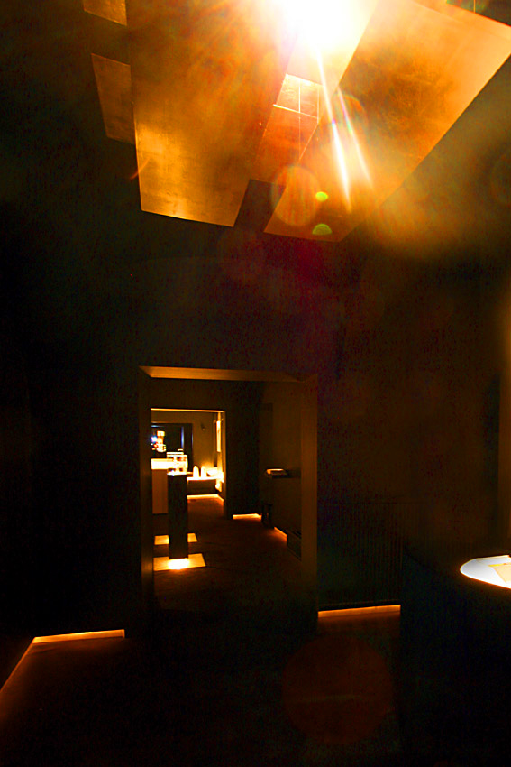
6. Puredistance Perfume Lounge Vienna
Elena Sopadzhieva - Int. Sales Manager

In the best tradition of the Wiener Werkstätte fine arts, architectural arts and decorative arts are all united in the Puredistance Perfume Lounge in the heart of Vienna. Entering the Puredistance Lounge is nothing less than a stunning experience due to its mystical atmosphere and simple beauty.

The concept of creating a central meeting place where people that are attracted to the concept of Puredistance can meet in an informal atmosphere was the reason for establishing the Puredistance Lounge in Vienna. The Lounge is located at the well known Franziskanerplatz; one of the most central and authentic squares in Vienna.

In a very safe and secured setting, at the end of a gorgeous passage, the Lounge acts as a meeting place, not only for Puredistance workers, but also for customers, business relations, agents and other people that like to drop by.
Puredistance Perfume Lounge Vienna

Architectural lighting specialist Philipp Metternich was responsible for the interior design of the Lounge. After making career in London and New York Mr. Metternich returned to his hometown Vienna where he started the challenging Puredistance Project in the beginning of 2007.

The Lounge is divided in three parts that all have their own function. The reception area, the exhibition area and the actual Lounge that is perfectly suited for relaxing while feeling far away from the bustle and hurry of daily life.

7. Design and Manufacturing
Two men that played an extremely important role in the realization of Puredistance are Klaus Arco and Sander Sinot.

Sinot, from Sinot Design in Laren, The Netherlands, was responsible for the unique design of the crystal column while Arco, the vice president internal operations of the consumer goods business division of Swarovski, Wattens, Austria, had to find the complex ways to execute the stunning design in the high quality crystal, Swarovski is famous for.
Engraving in the cap of a Crystal Column 'Crystal & Steel'

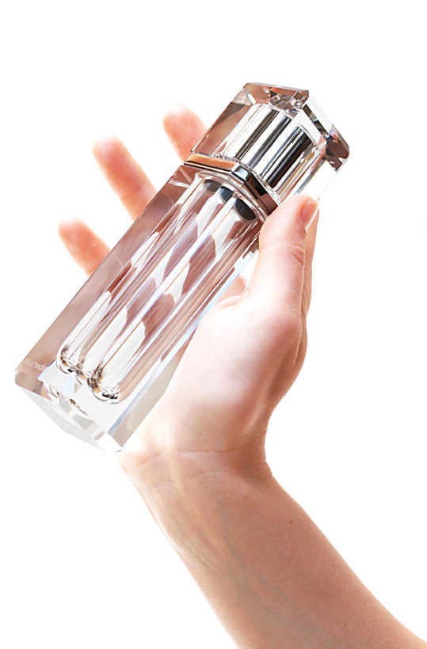
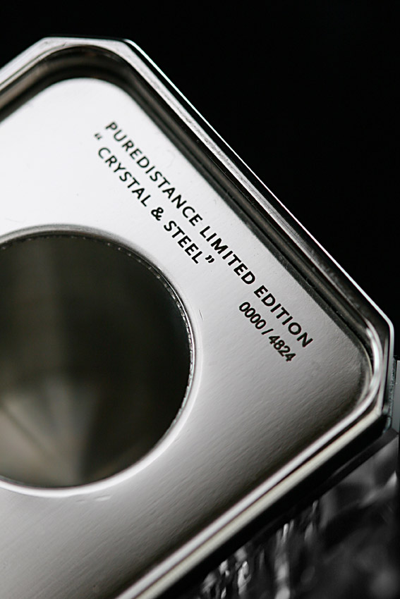
Both emphasize the enthusiasm with which they have worked on the project. Arco: “Mr. Vos was 100 % committed to it. His philosophy deeply impressed me and he wanted to realize this project with the best partners only – be it design, fragrance, packaging, or finally the crystal flacon. Mr. Vos’ request for high quality in all respects for his Puredistance project was finally crucial for Swarovski’s decision to contribute.”

According to Sinot, the cooperation with Mr. Vos, the founder of Puredistance, was very pleasing. “As long as the designer and his customer agree on what the final result should be, the process will be fairly quick and motivating. It was clear what Mr. Vos wanted and for me it was a delight to work with the concept of Puredistance. In a sense, it was designing an illusion that was already there and that is always great to do.”

Maybe the most tricky part in the entire process of developing Puredistance was matching the initial design of the flacon with the possibilities and impossibilities of carrying out that design in Swarovski crystal which is – because of its outstanding quality – very difficult to process. “A good example,” Arco explains, “is the hemisphere at the bottom of the flacon, which called for a completely new and special production tool. It took weeks of masterminding, experimenting and optimizing until we found the appropriate solution and developed the special tool, which allowed us to produce the cylindrical hole and the perfect hemisphere at the bottom of it.”
Crystal Column without Perfume Spray

It is this skillful craftsmanship that contributes to the superiority of Puredistance. Sinot even considers this to be one of the main features: “Puredistance, like the name indicates, is a very pure thing. This purity is clearly reflected in the design. The skills with which this design has been translated to a crystal object are so great that it actually exceeds all competition.”

Also Arco thinks Puredistance can easily compete with any other top fragrance label on the market. “The flacon may seem beautifully simple from the design point of view, but technical wise it is quite complex. The big surfaces and straight facets make it easy to spot the tiniest production mistake. Therefore everyone gave their best to ensure quality and reproducibility.
Crystal Column 'Crystal & Steel' 1750 Euro

Now, in the end, I am highly satisfied with the result. Everybody who was involved in realizing this project can be proud of this very exclusive product, which is finally in trade now!”

8. Pure Swarovski Crystal
Made of the famous Swarovski crystal the Puredistance Crystal Masterpiece of superb clarity features perfectly faceted edges and includes two plates of high-grade polished steel or 24 carat gold plate. The flacon is mostly handmade. Swarovski Crystal has over a hundred years of history and is considered by many to be the finest quality, full-lead crystal up to date. It contains a minimum of 32% PbO, making the crystal optically very pure. This Crystal Masterpiece is exclusively produced by Swarovski for Puredistance.
Detail Cap Crystal Column

9. About the Founder


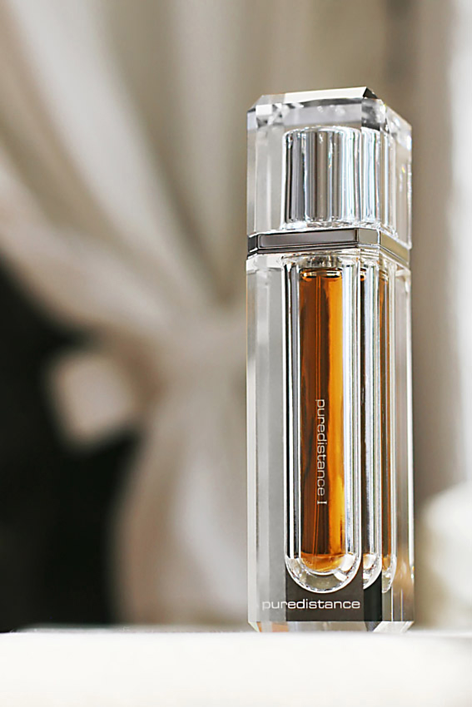
It is in an austerely renovated church in the town of Groningen in the North of Holland, that Jan Ewoud Vos, the originator of Puredistance, created the result of a long cherished dream: an object of purity and timeless beauty.

After having sold businesses that had their focus on more perishable products, he in the year 2001 started his difficult but steady search. Now, seven years later, Puredistance is ready to be experienced and cherished by others. “While for me the end has come to a phase of discovering the inner beauty of Puredistance, now is the time for others to experience and enjoy Puredistance.”
Jan Ewoud Vos - Founder Puredistance

Typical of the maturation of the concept of Puredistance was the natural way in which the process took place. “By never con-ceding to beauty and purity, an almost predestinated process started wherein the right people could eventually fully contribute to an ever growing concept, closing in on a result that is faithful to its basic assumption,” Jan Ewoud Vos explains.
Engraving in the cap of a Crystal Column 'Crystal & Gold'

“Everybody was given all the time they needed to achieve the ultimate and when I now hold the Puredistance Crystal column in my hands, I sense the energy and soul that all of us put in it. It’s this soul that really moves ones that see it, smell it and touch it. Maybe its difficult to comprehend, but it’s the magic of Puredistance.”

True beauty lasts forever but all good things come slowly. Jan Ewoud Vos is well aware of the fact the story of Puredistance is far from written yet. The product development phase may be completed, ahead lies the challenge of introducing Puredistance to the outside world.

Jan Ewoud Vos feels it is important to let things evolve in a natural way. “Since several decades, people have conceived a very distinct image of what a perfume is about. And that image does not fit Puredistance. This will make it harder for us to be noticed. Puredistance is not made to last for a few years, like most new perfumes do, it’s made to last forever.

Therein also lies strength. We don’t need to rush things. It will take time, but it will happen. For as I’m concerned: also this is predestinated. Real beauty will never go unnoticed.”
Crystal Column 'Crystal & Gold' 2750 Euro

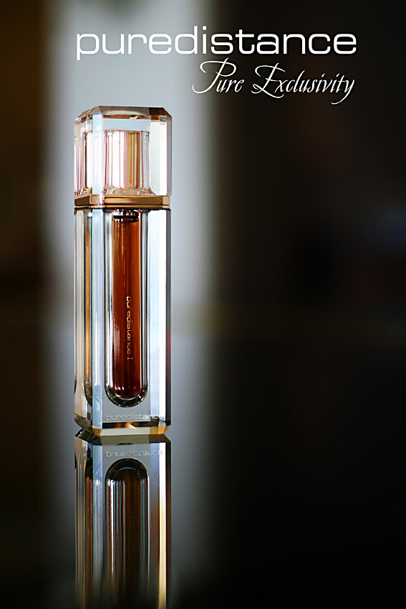
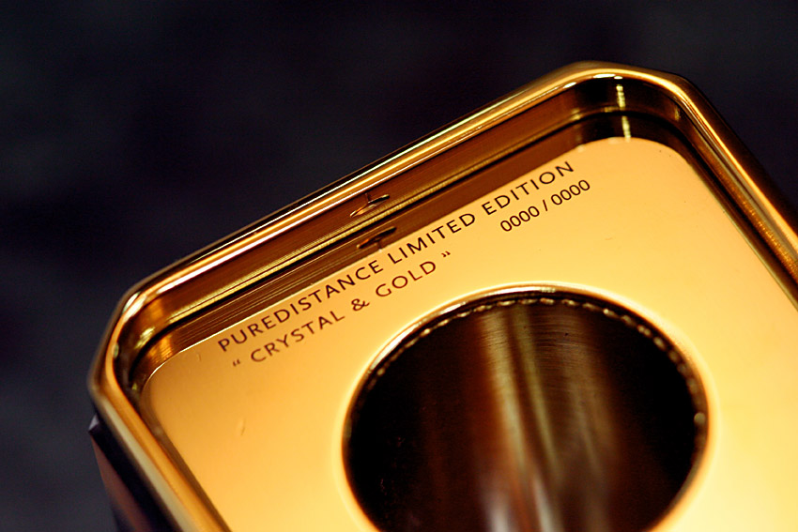
Of course Jan Ewoud Vos is proud of the materialization of his dream: “Every time I see Puredistance I’m struck by the fact that it still deeply intrigues me. It’s the elegance of the flacon in combination with its weight and the complexity of the scent. It’s of a deceptive simplicity, seemingly simple but with much deeper grounds.

Puredistance feels like it has always been there and will be there infinitely.”

10. Pure Exclusivity
“It just seems like musicians want to sell a few records and put out a perfume line. And I think it’s so sad! Music has been so much more...”

Though Moby, who is quoted here, thus tries to express his feelings about the ongoing commercialization of the music industry in the last decades, he accidentally names an important development in the cosmetics industry. It’s a sign of current time. The artist – whether he is a musician or a perfumer – is not longer thought to be able to survive in what has become an increasingly competitive industry, unless he surrenders to the contemporary rules of that industry.

In general can be said that introducing something to the worldwide market has become so expensive because of the tremendous marketing involved, that the profits made can not weigh up to those marketing costs already made.

For the same reason, one can be sure that for every 50 Euros odour you buy at one of the big cosmetics stores, only a few Euros you pay are the actual costs of producing it. It is not about the song or the odour anymore, one pays for the marketing machine around the products. Many people are so used to this mechanism, that they don’t even recognize it anymore, nor question it.

The process of commercialization in the perfume industry really had its start in the interbellum period. In the decades before that, perfumery had become more than a somewhat mystically veiled form of art, performed by scent mixers that directly stem from the medieval alchemists. Production processes were more or less standardized and in the big European and American cities people that had developed a particular fine perfume, started their own perfume houses and boutiques. Those men and women were artists that, if their art was good enough, found their audiences and sometimes became very famous.
Crystal Column 'Crystal & Gold' 2750 Euro

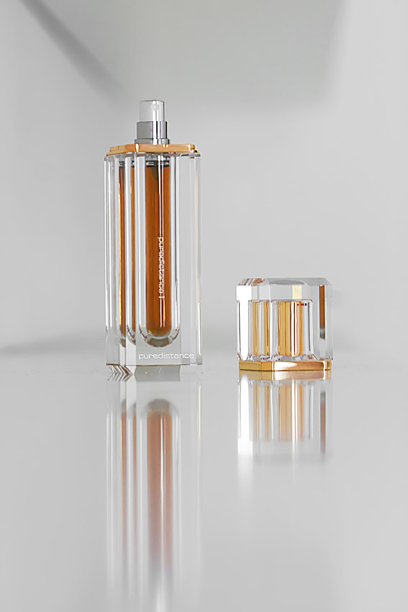
This period in the history of perfumery is the period Puredistance feels connected with and in a sense recalls longingly. The period in which it was all about quality, service and exclusivity. Simple and natural, a wonderful fragrance in a stunning flacon, created by an artist. A perfume could once again be an individual expression, a choice made as evidence of elegance and good taste.
Puredistance Perfume Lounge Vienna

That characterizes Puredistance best and is a unique renewed sound in the crazy world of cosmetics. And in a world where everybody tries to be special and have own identity, Puredistance remembers the words of one of the pioneers in the fragrance industry: Gabrielle Bonheur “Coco” Chanel…

“In order to be irreplaceable one must always be different.”

11. Mystery and Paradox
When taking a closer look at Puredistance – the fragrance, the flacon or the entire concept – one can’t deny perceiving a sense of contradiction: after the initial experience of simplicity and beauty, Puredistance appears not to be just that.

It is these apparent contradictions – paradoxes in Puredistance – that keeps you captivated. Just a good smell or a stunning flacon is not enough. As British writer William Somerset Maugham said:
“beauty is a bit of a bore”.

Contradictions are everywhere, as well in the surrounding world as in ourselves. They give perspective in life and allow us to judge. They are part of the complexity of things that makes life interesting. This same complexity makes Puredistance not just beautiful, but intriguingly beautiful.

The crisp and sparkling crystal that looks as if it - with confident gashes of the sharpest sword - has been cut from the brightest natural crystal allows light to refract in the purest colors. This clearness seems to be in mysterious contradiction with the setting in which it is presented in its home base in Vienna: a black surrounding wherein the little golden light in a subtle way reveals the effect of the crystal.
Cap Crystal Column 'Crystal & Gold'

A minimalistic paradox: just the smallest rays of light show more of the magnificent qualities of the crystal than a big spot light could ever do.

These paradoxical contradictions can also be found in the perfume itself. Though the effect of an odour on human skin is always a mystery, what Puredistance makes to an outstanding achievement in perfumery is the bringing together of two opposites: coolness and warmth.

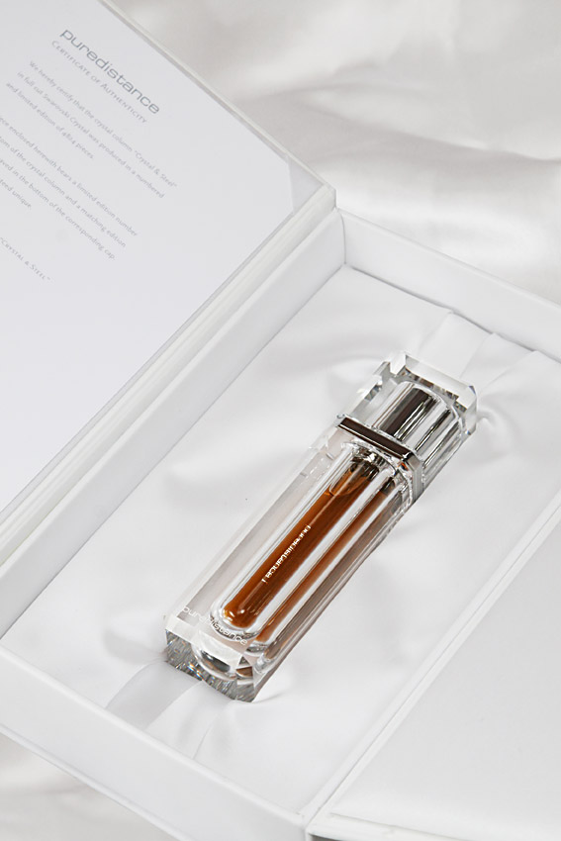
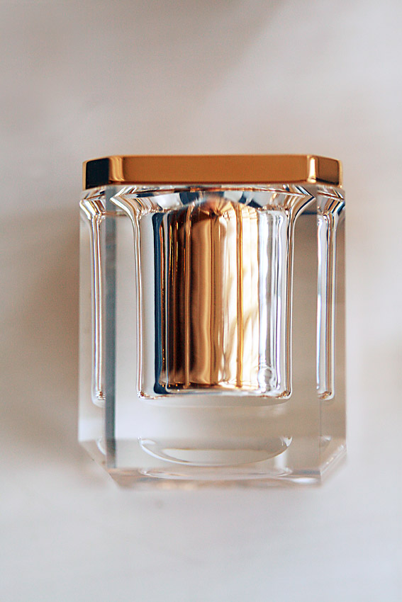
The first sensation being fresh and ozone-like, the scent reminds of contemporary tendencies in perfumery while when time passes, it picks up the warm aroma’s of jasmine, vertiver and white musk, thus referring to classical perfumery. Present and past brought together in elegance.

Since the magic of mystery is gone once the mystery is solved and contradictions are only interesting when noticed, not explained, here the clarification of the paradoxes of Puredistance ends.
Crystal Column 'Crystal & Steel'
in White Giftbox - 1750 Euro

But the only thing that will really do the trick is holding the crystal column in your own hand and smelling the perfume.

Then you can start your own Puredistance paradox-solving.

12. Puredistance Facts
The Puredistance Lounge
Capacity Lounge: up to 25 persons
Decoration Lounge: Black and Gold
The Lounge is divided in a reception area, an exposition area
and the actual Lounge.
Architect: Philipp Metternich, Vienna

The Perfume
Creator: Anni Buzantian, United States of America
Company: Firmenich, New York, United States of America
Quality: perfume, 32 % perfume oil
Top note: a fresh, ozone-tangerine blossom blend with a hint of
cassis, complemented with neroli bigarade
Middle note: magnolia, rose wardia & jasmine; parmenthia &
natural mimosa
Base note: sweet amber, vetiver
Content: 17,5 ml

The Crystal Column
Crystal Column 'Crystal & Gold' 2750 Euro

Designer: Sander Sinot, Laren, the Netherlands
Manufacturer: Swarovski, Wattens, Austria
Quality: 32% lead for optimal refraction
Inscriptions: in metal parts engraved, in crystal parts sandblasted
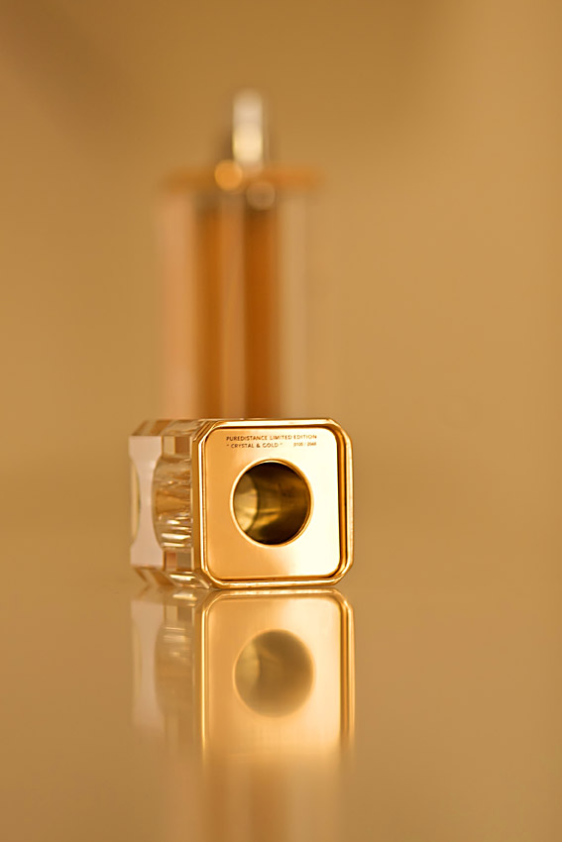
Two versions: Crystal & Steel and the Crystal & Gold
Weight: 750 grams - Dimensions: 40 x 40 x 157 mm
Maximum deviation: 0,2 mm

‘Crystal & Gold’ Limited Edition
Metal: the metal used is 24 carat gold-plated
Pieces: limited and numbered edition of 2048 pieces

‘Crystal & Steel’ Limited Edition
Metal: the metal used is polished high grade steel
Pieces: limited and numbered edition of 4824 pieces

Official Retail Prices 2008
Crystal & Steel incl. Perfume Spray 1.750 euro
Crystal & Gold incl. Perfume Spray 2.750 euro
Refill Perfume Spray 17,5 ml 165 euro

Puredistance
Franziskanerplatz 6 - 1010 Vienna Austria
telephone: 0043 1 513 55 18
internet: www.puredistance.com
email: vienna@puredistance.com
Opening hours: Monday to Friday from 10.00 to 12.30
and from 13.30 to 18.00 or by appointment.

